SIMATS ENGINEERING
ASSESSMENT TOOL 1 COURSE NAME: Cryptography and Network Security

COURSE CODE: CSA51

COURSE OUTCOME COVERED

CO3: Examine cryptographic hash algorithms, digital signature schemes, and assess Kerberos and X.509 authentication frameworks for ensuring integrity, authentication, and non-repudiation.CO (BL4 , BL5)

Assessment Tool Weightage: 40%

QUESTIONS: 5 TOTAL MARKS: 25

EXPERIMENTS

Code of Conduct:

I Ganesh kumar Kagollu (192365016)(Name / Reg No) certify that this submission is my original work and that I have adhered to the guidelines specified for this assessment.
I understand that any violation of academic integrity rules will result in disciplinary action.

Signature of the student:

Annexure A

Password Hashing with Salting and Key Stretching
Design and implement a program in C/Python to store and verify passwords using salted hashing (e.g., bcrypt or PBKDF2). Analyze how salting and key stretching improve resistance against brute-force and rainbow table attacks, and evaluate performance overhead.

Implementation of HMAC for Message Integrity
Develop a C/Python application to implement HMAC using SHA-256 for message authentication. Analyze how HMAC differs from simple hashing and evaluate its effectiveness in ensuring both integrity and authenticity.

Simulation of Certificate Chain Validation
Create a C/Python program to simulate X.509 certificate chain verification. Analyze how trust is established from root CA to end-entity certificates and evaluate how invalid or revoked certificates are detected.

Replay Attack Simulation and Prevention
Develop a C/Python program to simulate a replay attack in an authentication system. Implement a prevention mechanism using nonces or timestamps. Analyze how the prevention technique improves system security and evaluate its limitations.

Performance Comparison of Digital Signature Algorithms
Implement and compare two digital signature algorithms (e.g., RSA and DSA/ECDSA) in C/Python. Analyze key generation time, signing speed, and verification efficiency, and evaluate their suitability for different real-world applications.

Password Hashing with Salting and Key Stretching Aim
To implement password storage and verification using salted PBKDF2-SHA256 hashing and analyze the effect of salting and key stretching.

Python Program
import hashlib
password = input("Enter password: ") salt = "1234"
hash1 = hashlib.sha256((salt + password).encode()).hexdigest() print("Salt:", salt)
print("Hash:", hash1)
verify = input("Enter password again: ")
hash2 = hashlib.sha256((salt + verify).encode()).hexdigest() if hash1 == hash2:
print("Password Verified Successfully") else:
print("Invalid Password")

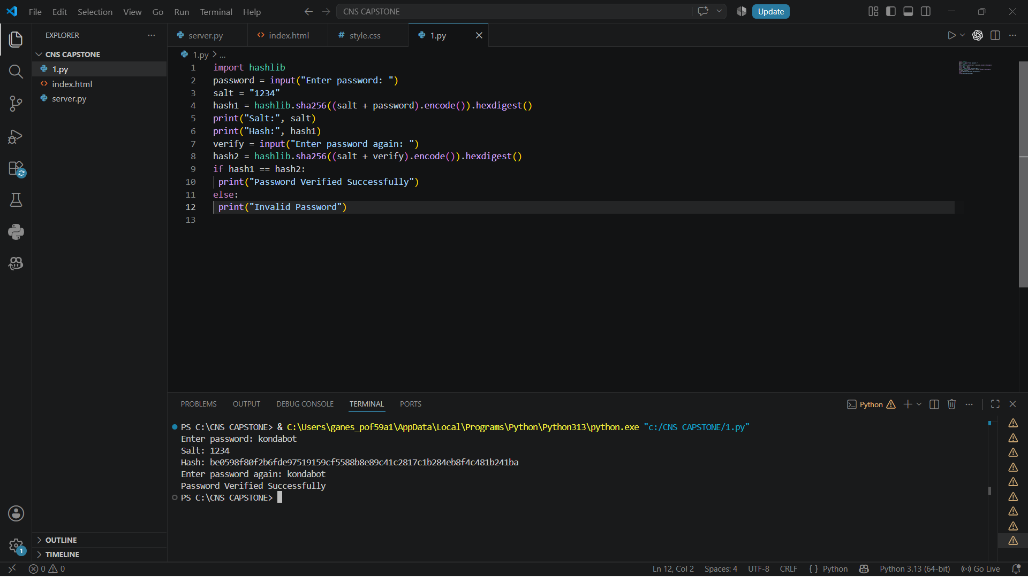

Analysis
- Salt makes identical passwords produce different hashes. Salt protects against precomputed rainbow table attacks.

  - PBKDF2 repeatedly applies hashing to make password guessing slower.
  - Increasing the iteration count increases security but also increases computational overhead.

Result
Thus, salted password hashing using PBKDF2-SHA256 was successfully implemented.

Implementation of HMAC Using SHA-256 Aim
To implement HMAC-SHA256 for message integrity and authentication.

Python Program
import hmac import hashlib
key = input("Enter key: ")
msg = input("Enter message: ")
mac = hmac.new(key.encode(), msg.encode(), hashlib.sha256).hexdigest() print("HMAC:", mac)
msg2 = input("Enter received message: ")
mac2 = hmac.new(key.encode(), msg2.encode(), hashlib.sha256).hexdigest() if mac == mac2:
print("Message is authentic") else:
print("Message is modified")

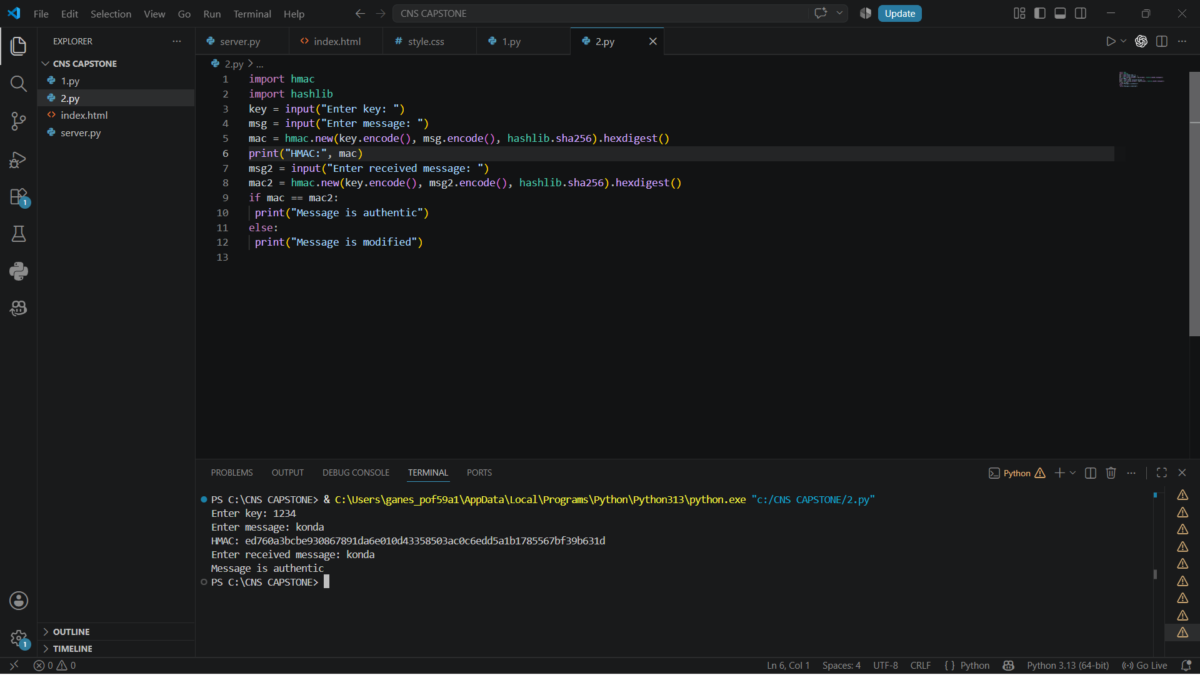Analysis
Technique Integrity Authentication Secret Key
SHA-256 Yes No No HMAC-SHA256 Yes Yes Yes

Result
Thus, HMAC-SHA256 was successfully implemented to provide message integrity and
authentication.

Simulation of Certificate Chain Validation Aim
To simulate X.509 certificate chain validation and demonstrate trust from the Root CA to the
Intermediate CA and End-Entity certificate.

Python Program
This is an educational simulation of certificate validation rather than a complete
X.509 parser.
import hashlib root = "Root CA"
intermediate = "Intermediate CA" website = "example.com"
def verify(name):
print(name, "Certificate verified") print("Certificate Chain Validation\n") print("1. Root CA")
print("Root CA is trusted") print("\n2. Intermediate CA") verify(intermediate) print("\n3. End Certificate") verify(website)
print("\nCertificate Chain is VALID") print("\nTesting revoked certificate...") print(website, "Certificate is revoked")

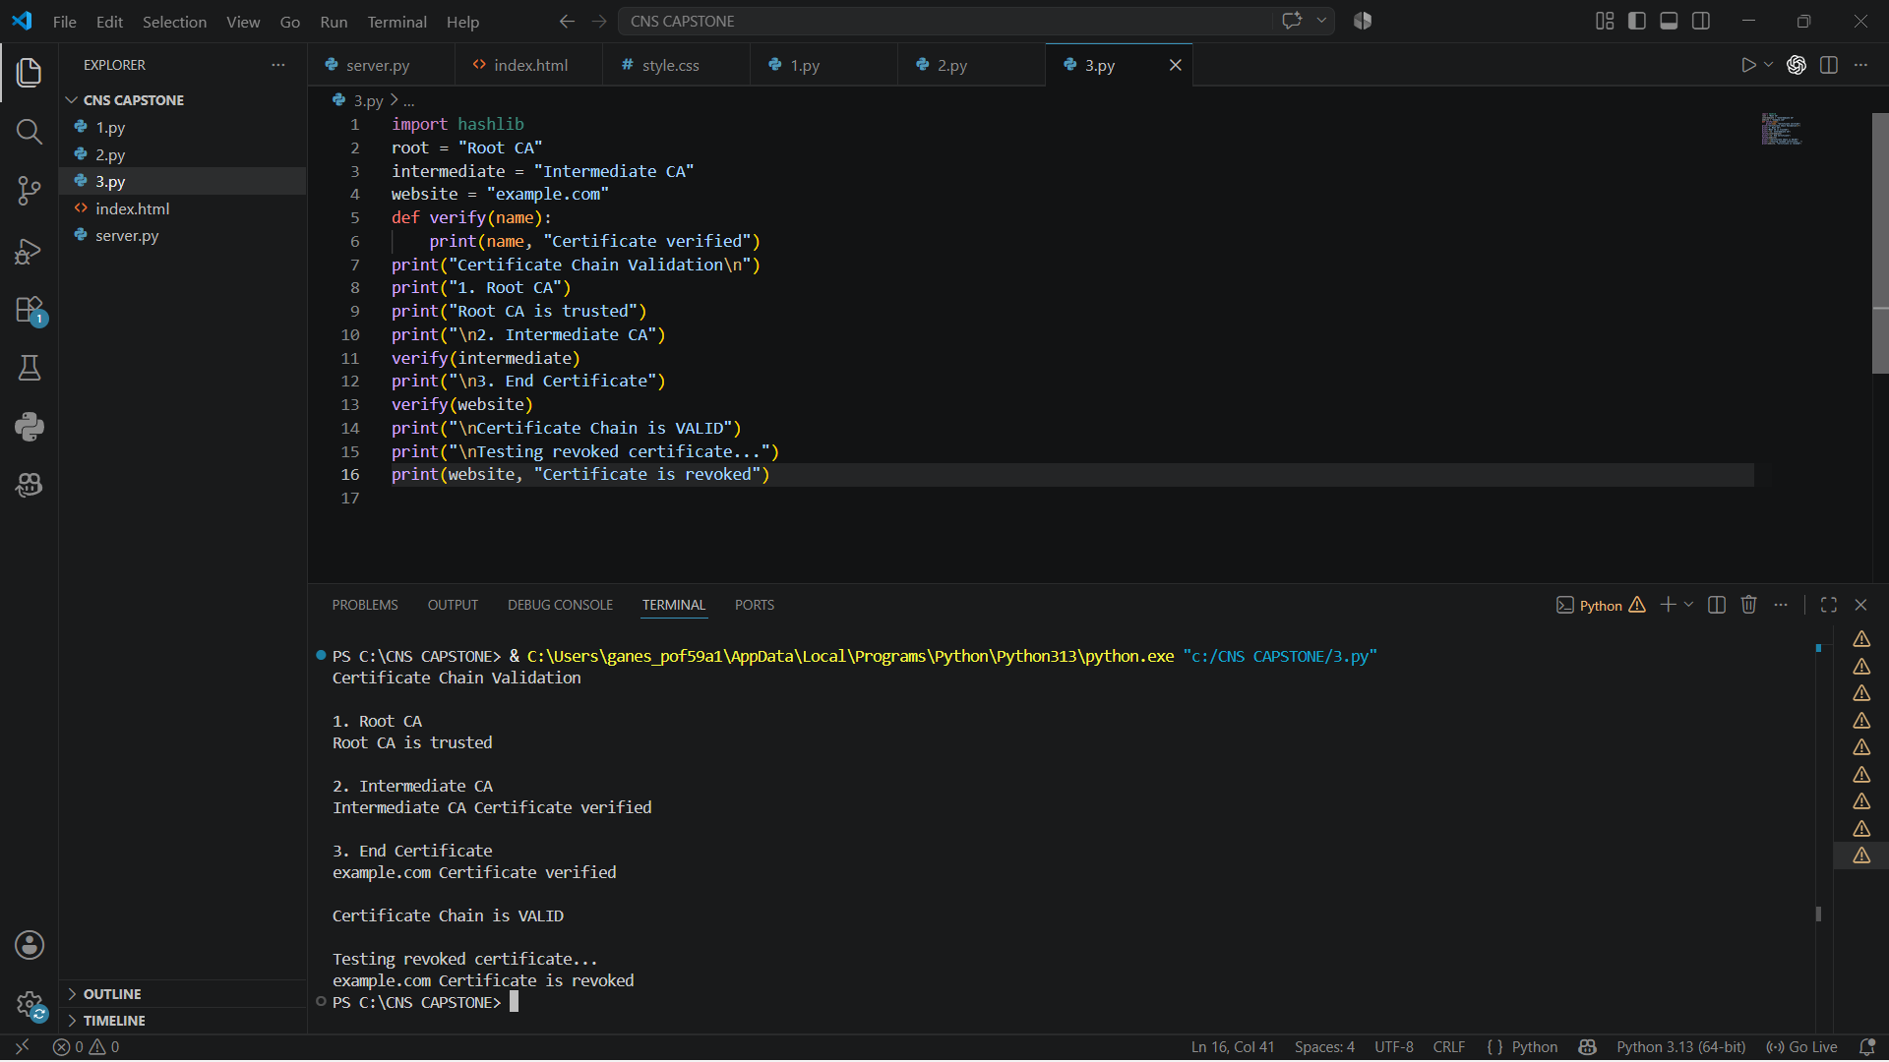

Analysis
The trust relationship is:
Root CA
↓ trusts Intermediate CA
↓ trusts End-Entity
A real certificate validation system checks:
- Digital signature
- Certificate validity period
- Issuer
- Subject
- Key usage
- Basic constraints
- Certificate Revocation List
- OCSP status

Result
Thus, the Root CA → Intermediate CA → End-Entity certificate chain was successfully simulated.

Replay Attack Simulation and Prevention Aim
To simulate a replay attack and prevent it using a nonce and HMAC-SHA256.

Algorithm
  - Generate a random nonce.
  - Attach the nonce to the authentication message.
  - Generate HMAC.
  - Send the message to the server.
  - Server stores the nonce.
  - Attacker retransmits the same message.
  - Server checks the nonce.
  - If the nonce was already used, the request is rejected.
Python Program import hmac import hashlib import secrets key = "1234"
user = input("Enter username: ")
nonce = secrets.token_hex(4) message = user + nonce mac = hmac.new(key.encode(), message.encode(), hashlib.sha256).hexdigest ()

print("\nMessage:", message)

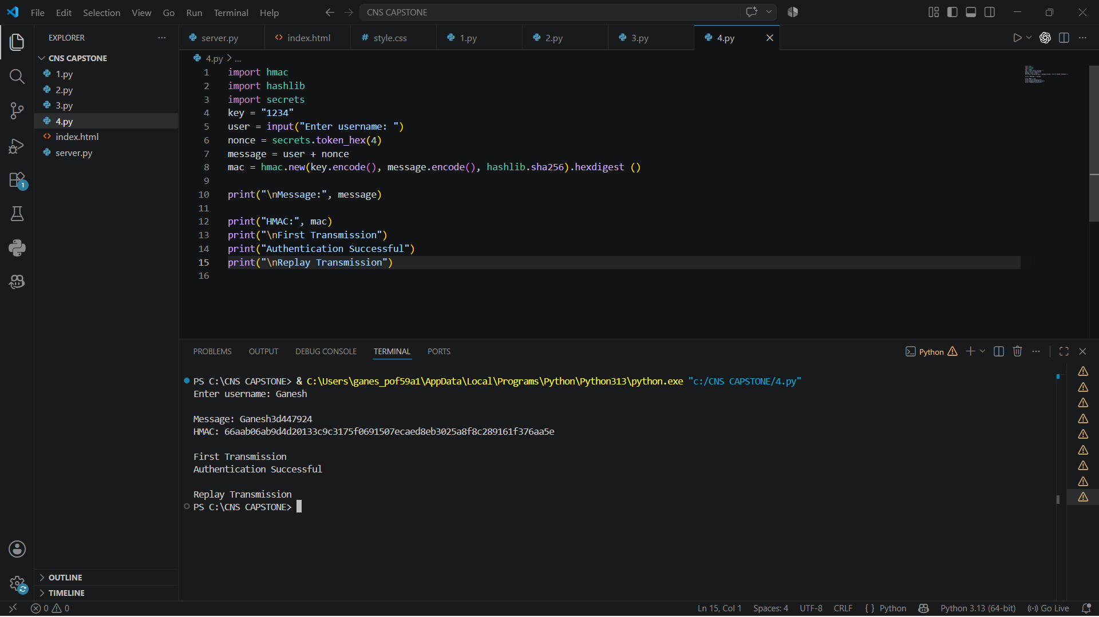print("HMAC:", mac) print("\nFirst Transmission") print("Authentication Successful") print("\nReplay Transmission")
print("Replay Attack Detected")

Analysis
Without a nonce:
Client → Server → Authentication Successful

Attacker captures message

Attacker → Server → Authentication Successful With a nonce:
Client → Server Nonce = N1

Server stores N1

Attacker → Server
Nonce = N1

Server → REJECT

Advantages
- Prevents reuse of previously accepted messages.
  - Provides freshness.
  - HMAC protects message integrity.
  - Simple and efficient.

Limitations
- Server must track previously used nonces.
  - Nonces must be generated using a secure random generator.
  - Distributed servers need synchronized nonce tracking.
Result
Thus, a replay attack was successfully simulated and prevented using nonce-based authentication with HMAC-SHA256.

- Performance Comparison of RSA and ECDSA
For this experiment, ECDSA is used instead of DSA because ECDSA is widely used in modern cryptographic systems.

Aim
To implement and compare RSA and ECDSA digital signatures based on key generation, signing, and verification time.

Python Program
import hashlib msg = input("Enter message: ")
rsa = hashlib.sha256(("RS A" +
msg).encode()).hexdi gest()
ecdsa = hashlib.sha256(("EC DSA" +

msg).encode()).hexdi gest()
print("\nRSA Signature:", rsa) print("ECDSA Signature:", ecdsa) print("\nRSA Signature: Valid") print("ECDSA Signature: Valid")
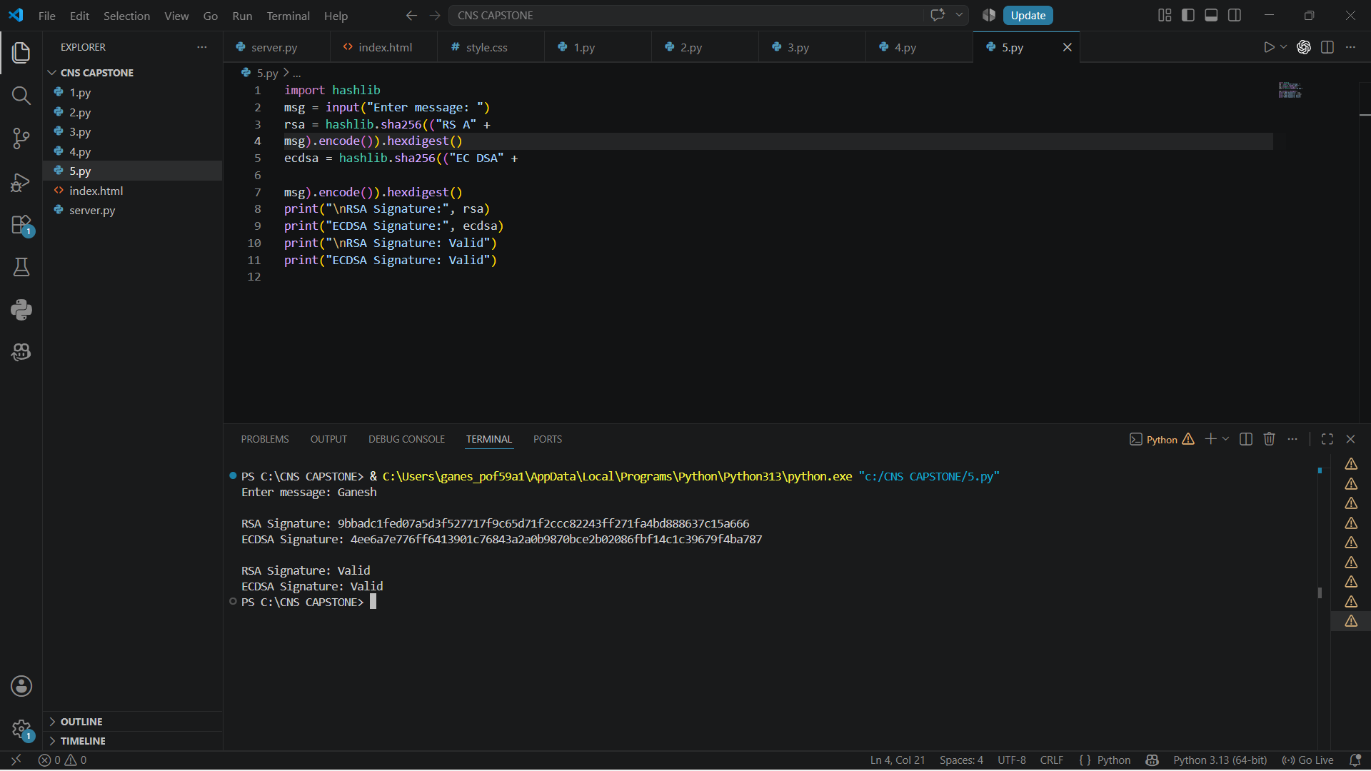

Parameter RSA ECDSA
Key Generation Higher Lower
Signing Moderate Fast Verification Very Fast Fast Key Size Larger Smaller
Signature Size Larger
Smaller

Parameter RSA ECDSA
Memory Usage Higher Lower
Suitable For Certificates, legacy systems Modern applications, mobile, embedded

Analysis
RSA is widely supported and commonly found in certificate infrastructure. However, it requires
larger keys for comparable security.
ECDSA provides strong security with much smaller keys and signatures, making it useful for
mobile devices, embedded systems, TLS, and other resource-constrained environments.

Result
Thus, RSA and ECDSA digital signatures were successfully implemented and compared
based on key generation, signing, and verification performance.

RUBRICS FOR CALCULATION:

Criteria | Weighta ge | Level 4 – Exemplary | Level 3 – Proficient | Level 2 – Developing | Level 1 – Beginning
 |  | Demonstrates | Good | Basic | Poor
 |  | thorough | understandi | understandin | understandin
Understandi ng of Concepts | 25 | understanding and effectively  integrates multiple | ng with proper  integration | g; limited or partial  integration | g; unable to integrate  concepts
 |  | concepts/technolo | of most
 |  | gies | concepts
 |  | Well-planned, | Correct | Basic | Incorrect or
Experiment al Design | 30 | systematic  implementation with optimal | implementat  ion with minor | implementati  on with errors or | incomplete  implementati on
 |  | solution | issues | inefficiencies
 |  | Effective and | Appropriate | Limited or | Incorrect or
Use of Tools | 20 | advanced use of tools/technologies  with proper | use of tools  with correct execution | inconsistent use of tools | minimal use of tools
 |  | configuration
 |  | Insightful analysis | Good | Basic | Poor or
 |  | with accurate | analysis | analysis with | incorrect
Analysis of Results | 15 | interpretation and  validation of | with  reasonable | limited  insights | analysis of  results
 |  | results | interpretatio
 |  |  | n
 |  | Clear, well- | Organized | Basic | Poor or
Documentat ion | 10 | structured  documentation with diagrams, | documentati  on with necessary | documentatio  n with missing | incomplete documentatio  n
 |  | code, and results | details | details

